Lab Supplements
Controlled synthesis of K₂[Cu(C₂O₄)₂]·4H₂O and K₂[Cu(C₂O₄)₂]·2H₂O (C₂O₄²⁻ = oxalate dianion) - A laboratory experiment for undergraduates
Ai-Li Cui, Jing-Zhi Wei, Jin Yang, and Hui-Zhong Kou*
Department of Chemistry, Tsinghua University, Beijing 100084, P. R. China; * kouhz@mail.tsinghua.edu.cn
Experiment Procedure
(with notes/suggestions for the instructor)
Experimental background:
The oxalate anion, C₂O₄²⁻ acting as either a unidentate, chelating or bridging ligand (1), is capable of coordinating with metal ions in different ways, thus forming versatile structures such as bimetallic dimers, trimers, tetramers, 1D chains, other 2D networks and 3D lattices (2). The oxalate bridge has the remarkable ability to transmit magnetic coupling between paramagnetic metallic centers, which attracts much attention in the field of molecule-based magnets (3). Therefore, complexes 1 and 2 can be used as the starting materials for the design of new systems to improve classical physical properties (ferromagnetism (4) and metal-organic frameworks (5)).
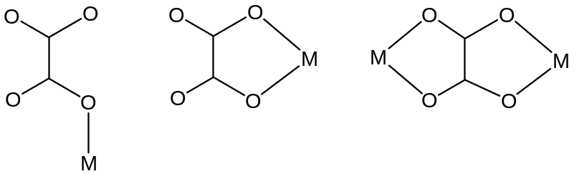
Scheme 1. Coordination modes of the oxalate anion.
Complexes 1 and 2 have been previously prepared by different methods (6,7). The dihydrate species can be conveniently prepared by the reaction between CuSO₄·5H₂O and K₂C₂O₄ in a mole ratio of 1:4 at 90°C (8). However, the synthesis of the tetrahydrate compound is complicated, and it seems that the compound was only a byproduct in the reported reaction (6). Crystal structure determinations show that the products have different molecular structures: the tetrahydrate complex is two-dimensional, and the dihydrate is three-dimensional. However, the coordination environments of Cu(II) for two complexes are nearly identical: the Cu(II) ion is surrounded by four oxygen atoms from two oxalate anions (Scheme 2). The cell parameters of K₂[Cu(C₂O₄)₂]·4H₂O are a = 3.7770 Ǻ, b = 14.819 Ǻ, c = 10.756 Ǻ, α = 90°, β = 93.180°, γ = 90°, V = 601.1 Ǻ³ (6), while the cell parameters of K₂[Cu(C₂O₄)₂]·2H₂O are a = 8.7092 Ǻ, b = 10.3904 Ǻ, c = 6.9486 Ǻ, α = 121.110°, β = 82.956°, γ = 110.848°, V = 501.6 Ǻ³ (7). In this experiment, we can separately isolate single crystals of compound 1 or 2 from an aqueous solution of K₂[Cu(C₂O₄)₂] by controlling the concentration of the solution. The two compounds have different shapes: needle crystals correspond to the tetrahydrate compound and flat crystals to the dihydrate, which has been confirmed by determining the cell parameters of the two kinds of crystals. Therefore, we can easily distinguish them from their appearance. It is a good way that we do not inform the students which kind of crystal corresponds to which compound beforehand, and let the students find out the result through the water content analysis. This should arouse the students’ research interest. In addition, it is suggested that before coming to the laboratory, students should consult the references (6,7) and make clear the difference in the molecular structure of the two compounds.
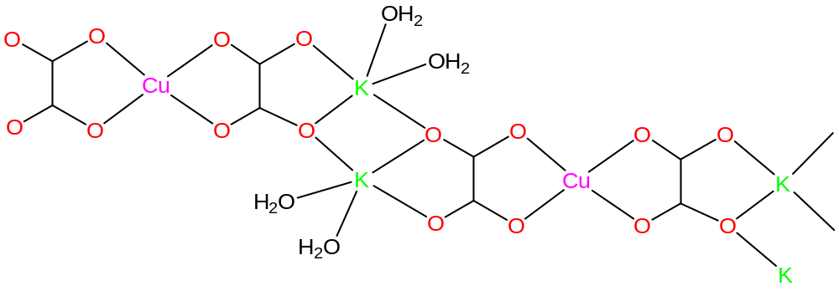
1
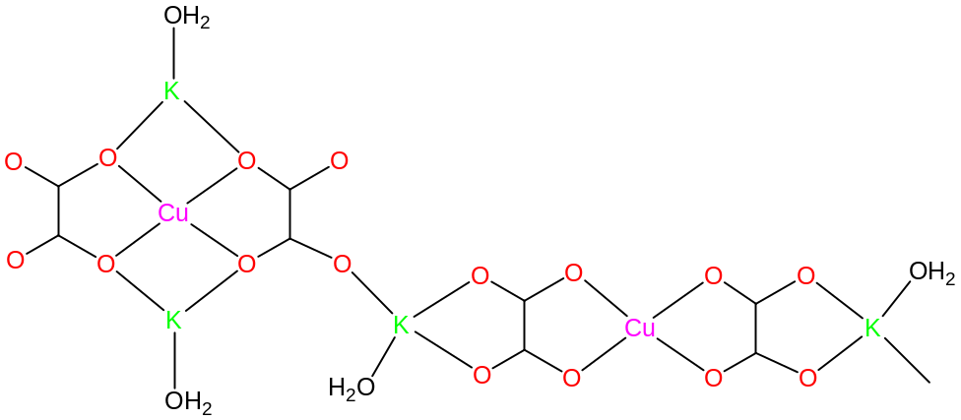
2
Scheme 2. Molecular structures of complexes 1 and 2.
Preparation of CuO:
Commercially available CuO can be used and gives similar experimental results. The reason we prepared CuO is that from the preparation the students can learn how to perform experimental operations, such as inorganic synthesis, suction filtration and washing. If time is not available, instructors can omit this procedure and use commercial CuO instead.
CuO can be easily prepared by reacting CuSO₄·5H₂O with an excess of NaOH (aq). Constant stirring should be employed to complete the reaction. The Cu(OH)₂ solid formed can be converted to black CuO by heating the mixture to boiling. Caution: Occasional stirring of the solution with a glass rod should be done to avoid splashing of the mixture. The resulting CuO solid was suction filtered, washed thoroughly (10 mL of water two times to remove the absorbed NaOH and Na₂SO₄) and transferred to a beaker together with filter paper.
2.0 g of CuSO₄·5H₂O (8 mmol) was dissolved in 40 mL of water in a 150-mL beaker. To this solution, an aqueous solution (10 mL) of NaOH (0.8 g, 20 mmol) was added with stirring (If magnetic stirrers are not available, it is alright to use glass rods). Heating the mixture gently will turn the blue precipitate to black. The product mixture was kept boiling for 15 min and then filtered while hot. The black solid CuO was washed twice with deionized water.
Synthesis of KHC₂O₄:
The KHC₂O₄-K₂C₂O₄ mixture can be prepared by the reaction of H₂C₂O₄ with K₂CO₃ in a mole ratio of 3:2. Appropriate heating (85°C) accelerates the reaction. Care should be taken to avoid splashing of the liquid by adding K₂CO₃ in small portions and stirring. In addition, the amount of C₂O₄²⁻ should be more than 3 times that of Cu²⁺. It was found that some students obtained light blue cloudy precipitate (CuC₂O₄) because they used less H₂C₂O₄ (the mole ratio of Cu²⁺:C₂O₄²⁻ was close to 1:1).
3.0 g of H₂C₂O₄·2H₂O (24 mmol) was dissolved in 40 mL of water in a 250-mL beaker, and the solution was warmed to 85°C. To this warm solution, solid anhydrous K₂CO₃ (2.2 g, 16 mmol) was added in small portions. The resulting clear solution was stored for use in the synthesis of K₂[Cu(C₂O₄)₂].
Synthesis of a hot solution of K₂[Cu(C₂O₄)₂]:
In order to have satisfactory yield, the filter paper can be transferred to the solution of KHC₂O₄ because there is some CuO adhering to the paper. However, the paper should be removed before filtration and fragmentation of the paper should be avoided. The mixture is suction filtered while hot, and the hot filtrate is transferred to a 100-mL beaker for concentrating. (Caution! The suction funnel and bottle should be warmed beforehand.)
The prepared CuO was added to the KHC₂O₄ solution with vigorous stirring at 80°C. After complete dissolution of CuO, the mixture was rapidly filtered while hot to remove any insoluble solids (Caution! The suction funnel and bottle should be warmed beforehand.). Then the hot filtrate (ca. 50 mL) was transferred to a 100-mL beaker and used for the crystallization of K₂[Cu(C₂O₄)₂]·4H₂O or K₂[Cu(C₂O₄)₂]·2H₂O according to the procedure shown below.
Synthesis of K₂[Cu(C₂O₄)₂]·4H₂O and K₂[Cu(C₂O₄)₂]·2H₂O:
It is important to strictly control the concentration of the hot K₂[Cu(C₂O₄)₂] solution. Generally speaking, dilute solutions give rise to the tetrahydrate compound, while concentrated solutions generate the dihydrate. However, attention should be paid to the following three items.
1. Co-crystallization of compounds 1 and 2. Sometimes students may obtain a mixture of compounds 1 and 2 upon the preparation of the flat compound 2. This is due to inappropriate control of the reaction conditions. Student should be aware that keeping crystals of 2 in the mother liquid for some time may cause the crystallization of 1 (not conversion but co-crystallization). This is due to the change in the concentration of the solutions after crystallization of 2. From these experiments, students can learn that the concentration of the solution will affect the crystallization of the products, and can know how to avoid obtaining a mixture of compounds 1 and 2.
2. Conversion of the needle crystals to flat crystals. We have observed that during the crystallization of compound 1 the needle crystals turn to flat crystals when shaking the beaker or stirring the solution. On this basis, students can conclude that compound 1 is not stable, and can be converted to the more stable compound 2 under certain conditions (e.g. shaking, and standing in the mother liquid overnight). Further evidence is the decay of the needle crystals exposed to air. Compound 1 slowly loses two water molecules and converts to the dihydrate compound 2. We inform the students of this characteristic beforehand. Students will show intense interest in the conversion, and learn the thermodynamic stability of complex 2.
3. The growth of large crystals. Students should be aware that slow cooling of the solution usually gives large crystals. Students observed that if the hot solution was cooled by cold water, small crystals will appear. When the hot solution was cooled in air, large crystals can be obtained.
During the period of cooling, students should observe the occurrence and the growth of the crystals.
Synthesis of K₂[Cu(C₂O₄)₂]·4H₂O: The solution can be condensed by evaporation to 40 mL in a hot water bath. This residual solution was set aside and was cooled to room temperature, and dark blue needle crystals are obtained and filtered. The needle crystals slowly decay at room temperature. Compound (1) was obtained with a yield of 80%.
Synthesis of K₂[Cu(C₂O₄)₂]·2H₂O: The solution was condensed by evaporation to 10 mL in a hot water bath. When the residual solution was cooled in air for 10 min, light blue flat crystals of (2) were obtained and filtered immediately. Compound (2) was obtained in a yield of 70 %.
Water content analyses:
Although the crystal shapes of two products are apparently different, it is straightforward to distinguish them by determining the water content. Student should be informed beforehand that the temperature for the dehydration should be controlled at 200±10ºC since the fully dehydrated product (K₂[Cu(C₂O₄)₂]) decomposes at ca. 250ºC. Therefore, gentle heating of the finely ground powder should be employed. Noteworthy is that it is necessary to grind the crystals as fine as possible in order to determine the water content more accurately. If a hot oil bath is not available, it is suggested to use NaCl powder (salt bath). If so, care should be taken to control the rate of temperature increase. It is alright that the speed of heating is fast (10°C/min), however it should be as low as possible (5°C/min) when the temperature reaches 150°C. Students may find that the tetrahydrate compound gives a lower water content than calculated. This is due to partial dehydration of the compound in air. If students obtain higher water contents, the only reason is that they overheated the powder and partial decomposition of the sample took place.
Finely ground (in a mortar) crystals of 1 or 2 (0.5 g) were placed in a ceramic crucible. After heating the sample at 200°C for 30 min, the sample was cooled to room temperature in air. Weigh the dehydrated sample, and calculate the water content.
Characterizations of the two compounds:
The infrared and visible spectra of two compounds are almost identical, and therefore it is impossible to distinguish them via the spectroscopic methods (Figures S1 and S2).
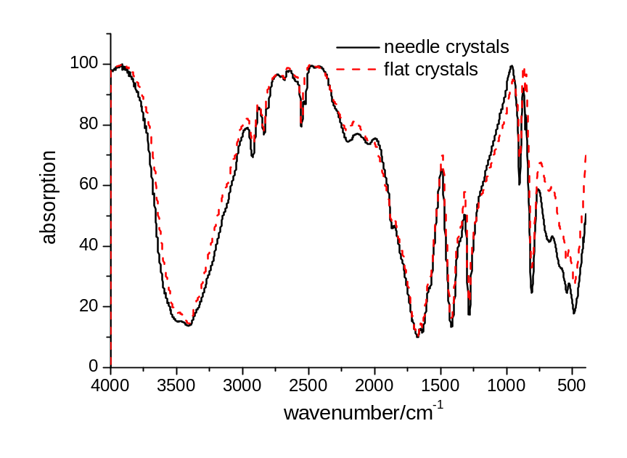
Figure S1. Infrared spectra of the two compounds.
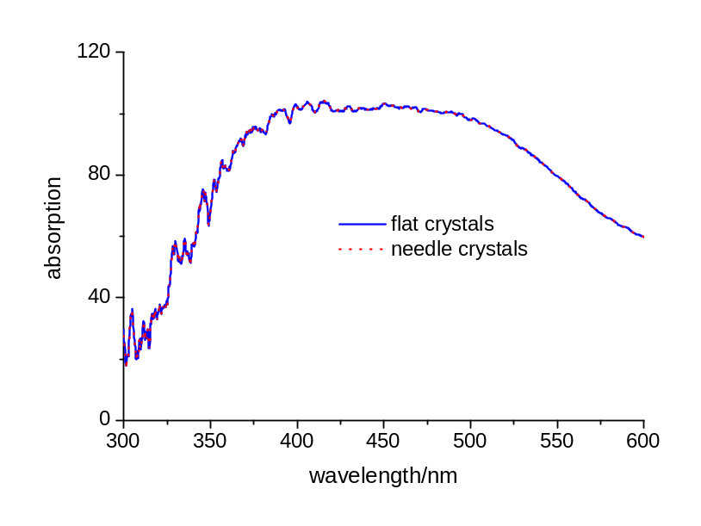
Figure S2. UV-vis spectra of the two compounds.

We have checked the purity of compounds 1 and 2 via powder X-ray diffraction (XRD) measurements. The peaks are in good agreement with calculated values (Figures S3 and S4).
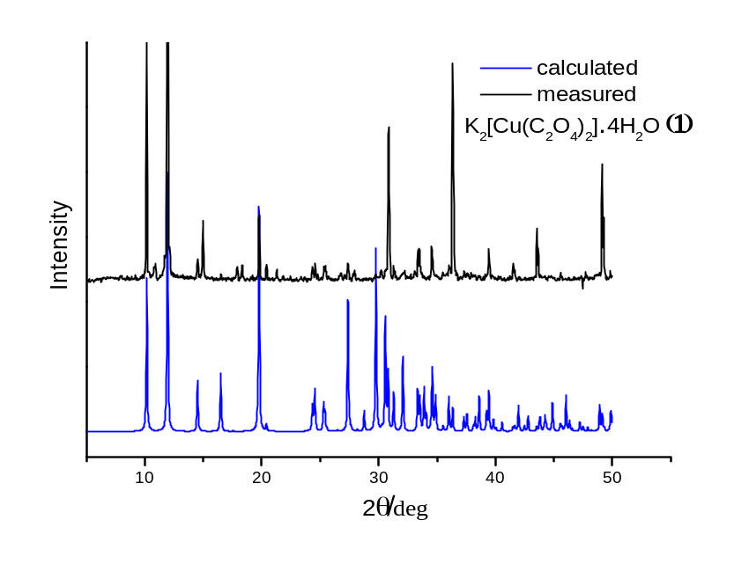
Figure S3 XRD analysis of K₂[Cu(C₂O₄)₂]·4H₂O (1). The black line is measured while the blue line is calculated according to the literature.
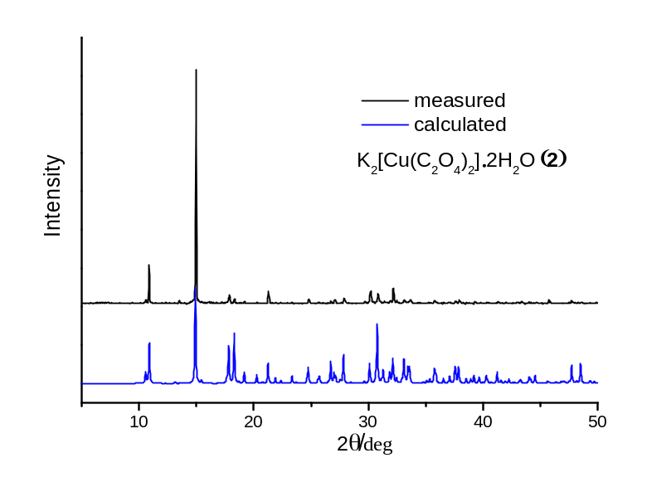
Figure S4 XRD analysis of K₂[Cu(C₂O₄)₂]·2H₂O (2). The black line is measured while the blue line is calculated according to the literature.
The dark blue needle crystals of K₂[Cu(C₂O₄)₂]·4H₂O (1) changed to the light blue flat crystals of K₂[Cu(C₂O₄)₂]·2H₂O (2) overnight while in the mother solution. Alternatively, the dark blue needle crystals K₂[Cu(C₂O₄)₂]·4H₂O (1) when heated to 90°C completely convert to K₂[Cu(C₂O₄)₂]·2H₂O. XRD analysis (Figure S5) confirms this transformation.
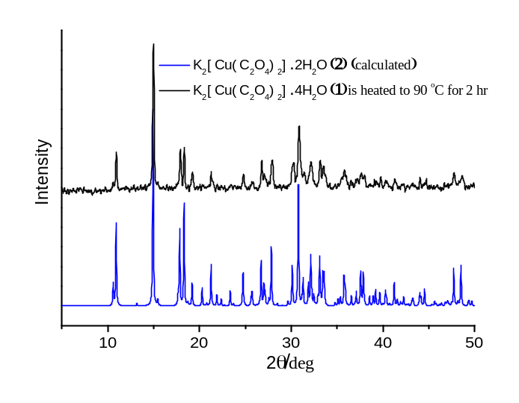
Figure S5 XRD analysis of the transformation of K₂[Cu(C₂O₄)₂]·4H₂O (1) to K₂[Cu(C₂O₄)₂]·2H₂O (2). The black line is experimental data from complex (1) heated to 90 °C for 2 hours, while the blue line is calculated data of K₂[Cu(C₂O₄)₂]·2H₂O (2).

TGA analysis of the two complexes shows that both complexes lose their water molecules at 150~250°C (Figure S6). Therefore, heating the samples at 200°C for 30min gives the dehydrated samples. Comparing the difference in weight of the samples can give the water contents.
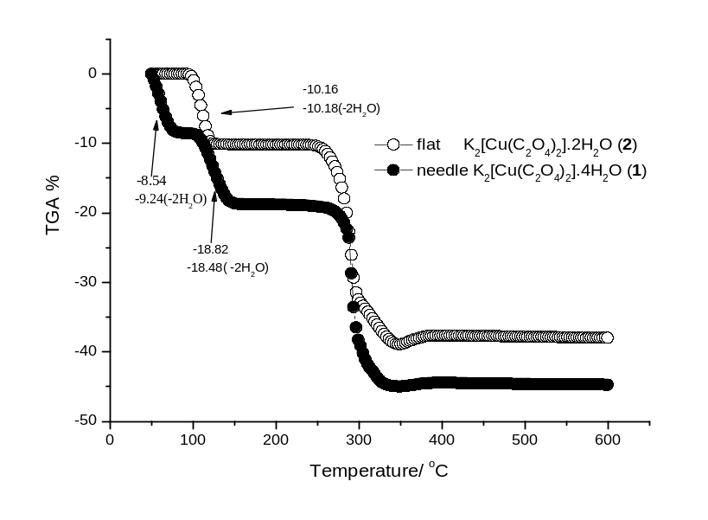
Figure S6. TGA analysis of complexes 1 and 2

Chemicals
H₂C₂O₄·2H₂O (CAS: 6153-56-6)
K₂CO₃ (CAS: 584-08-7)
CuSO₄·5H₂O (CAS: 7758-99-8)
NaOH (CAS: 1310-73-2)

Equipment
Beaker
Water bath
Suction filtration
Ceramic crucible
Glass rod
Pestle and mortar
Literature Cited
1. Oldham, C.; Wilkinson, G.; Gillard, R.D.; McCleverty, J.A. (Eds.). Carboxylates, Squarates and Related Species. Comprehensive Coordination Chemistry, vol. 2, Pergamon Press, New York, 1987, pp. 435.
2. Chisholm, M. H.; Macintosh, A. M. Chem. Rev. 2005, 105, 2949.
3. Coronado, E.; Galan-Mascaros, J. R.; Gomez-Garcia, C.J.; Ensling, J.; Gutlich, P. Chem. Eur. J., 2000, 6, 552-563.
4. Kou, H.-Z.; Sato, O. Inorg. Chem. 2007, 46, 9513.
5. Janiak, C. Dalton Trans., 2003, 2781.
6. Fan, J.; Sun, W. Y.; Okamura, T.; Yu, K. B.; Ueyama, N. Inorg. Chim. Acta 2001, 319, 240.
7. Weichert, T.; Lohn, J. Z. Kristallogr. 1974, 139, 223.
8. Inorg. Synth. Vol. VI, p. 1.

Questions for students:
- Explain this experimental phenomenon: Long standing of the flat crystals in the mother liquid results in the generation of needle crystals.
Answer: When flat crystals have deposited from the mother liquid, the solution becomes dilute. We have learnt that the needle crystals precipitated from a dilute solution.

- Why are the UV-vis spectra of two analogues nearly identical?
Answer: For transition metal compounds, the visible spectrum corresponds to d-d transitions of the metal ions. From the structure of two compounds, we can learn that the coordination environment of Cu(II) is very similar, i.e. square planar with four oxygen atoms of two oxalate ligands coordinated. Therefore, the energy for the d-d transitions should be similar, resulting in nearly identical UV-vis spectra of the two compounds.

- Illustrate which compound is more stable on the basis of experimental observations.
Answer: The dihydrate compound 2 is more stable considering that the tetrahydrate compound effloresces due to the loss of crystallization water molecules.
Experiment Procedure
(For students)
Rationale. Crystal engineering is important for functional materials. The factors that affect crystallization involve temperature, concentration and solvents. The primary goal of this experiment is to synthesize two different crystals by controlling the experimental conditions. The synthesis of K₂[Cu(C₂O₄)₂]·2H₂O (1) is a traditional experiment in the teaching curriculum. It can be easily prepared from the reaction of CuSO₄·5H₂O with K₂C₂O₄ at 90°C. However, there is a tetrahydrate analog K₂[Cu(C₂O₄)₂]·4H₂O that has been prepared by accident (2). Scheme 1 shows the molecular structures of the two compounds. In this experiment, K₂[Cu(C₂O₄)₂]·4H₂O and K₂[Cu(C₂O₄)₂]·2H₂O can be selectively prepared by controlling the concentrations of K₂[Cu(C₂O₄)₂] solutions. A dilute solution gives rise to one compound, while a concentrated solution generates another. The visible and the infrared spectra of the two compounds are identical. Therefore, it is impossible to distinguish them by spectroscopic studies. However, crystals of the two compounds have different shapes: flat and needles. Therefore, it is easy to distinguish them by appearance. Thermogravimetric analyses (TGA) show that two compounds lose their water molecules at 150°C, and decompose at 250°C (Scheme 2). Interestingly, the tetrahydrate compound can be converted to the dihydrate compound upon the partial loss of water molecules in air or in solutions. It is crucial to control the growth of the crystals because of the easy conversion. The present experiment can help students learn how to control the formation of the products, and help them to understand the factors that affect crystallization.
Scheme 1. Molecular structure of K₂[Cu(C₂O₄)₂]·4H₂O (upper) and K₂[Cu(C₂O₄)₂]·2H₂O (lower).
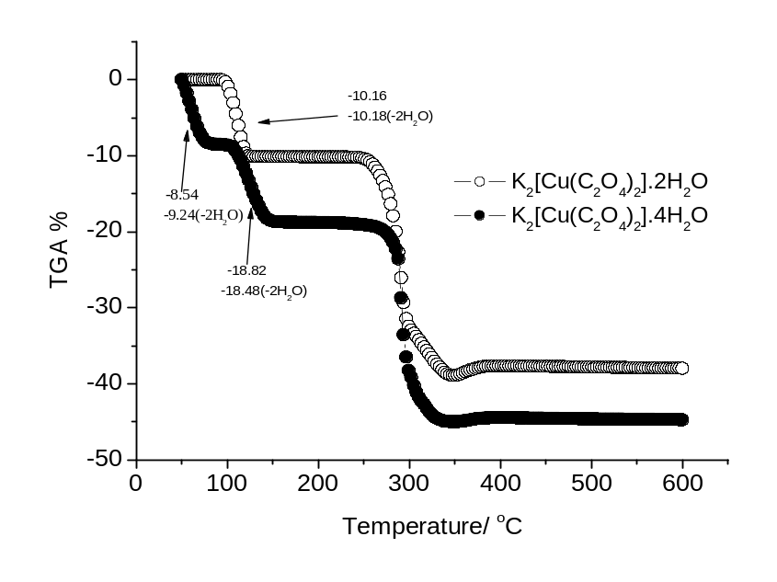
Scheme 2. TGA analysis of compounds K₂[Cu(C₂O₄)₂]·4H₂O and K₂[Cu(C₂O₄)₂]·2H₂O

Pre-lab question: What are the differences in the coordination environment of Cu(II) in compounds K₂[Cu(C₂O₄)₂]·4H₂O and K₂[Cu(C₂O₄)₂]·2H₂O? (Hint: read the literature (1, 2), and compare the Cu-O bond distances and the coordination configuration of Cu)
Literature Cited
1. Weichert, T.; Lohn, J. Z. Kristallogr. 1974, 139, 223.
2. Fan, J.; Sun, W. Y.; Okamura, T.; Yu, K. B.; Ueyama, N. Inorg. Chim. Acta 2001, 319, 240.

Procedure. Before coming to the laboratory, students should consult the two references (1,2), and learn the difference in molecular structures of the two compounds. The whole experiment can be divided into five steps.
(1) Synthesis of CuO. 2.0 g of CuSO₄·5H₂O (8 mmol) was dissolved in 40 mL of water in a 150-mL beaker. To this solution, an aqueous solution (10 mL) of NaOH (0.8 g, 20 mmol) was added with stirring (If magnetic stirrers are not available, it is alright to use glass rods). Heating the mixture gently turned the blue precipitate to black. Afterwards, the product mixture was kept boiling for 15 min and then filtered while hot. The black solid CuO was washed twice with deionized water.
(2) Synthesis of KHC₂O₄. 3.0 g of H₂C₂O₄·2H₂O (24 mmol) was dissolved in 40 mL of water in a 250-mL beaker, and the solution was warmed to 85°C. To this warm solution, solid anhydrous K₂CO₃ (2.2 g, 16 mmol) was added in small portions. The resulting clear solution was stored for use in part (3).
(3) Synthesis of a hot solution of K₂[Cu(C₂O₄)₂]. CuO prepared above was added to the KHC₂O₄ solution with vigorous stirring at 80°C. After complete dissolution of CuO, the mixture was rapidly filtered while hot to remove any insoluble solids (Caution! The suction funnel and bottle should be warmed beforehand). Then the hot filtrate (ca. 50 mL) was transferred to a 100-mL beaker and used for the crystallization of K₂[Cu(C₂O₄)₂]·4H₂O or K₂[Cu(C₂O₄)₂]·2H₂O according to the procedure shown below.
(4a) Synthesis of compound 1. The solution was condensed by evaporation to 40 mL in a hot water bath. This residual solution was cooled in air to room temperature. The dark blue needle crystals obtained should be filtered immediately. The needle crystals slowly decay at room temperature. Compound (1) was obtained with a yield of 80%.
(4b) Synthesis of compound 2. The solution was condensed by evaporation to 10 mL in a hot water bath. When the residual solution was cooled in air for 10 min, the light blue flat crystals of (2) are obtained and filtered immediately. Compound (2) was obtained in a yield of 70 %.
You may be asked by the instructor to grow large crystals of compound 1 or 2, and if so, just control the rate of cooling. Cooling the solution to room temperature in a period of 30 min, large crystals (~3 mm×3 mm for 1 and 10 mm in length for 2) can be obtained.
(5) Water content analyses. Finely ground (in a mortar) crystals of 1 or 2 (0.5 g) were placed in a ceramic crucible. After heating the sample at 200°C for 30 min, the sample was cooled in air to room temperature. Weigh the cooled dehydrated sample, calculate the water content, determine the chemical formula of 1 and 2, and analyze the results.
Questions:
- Explain the experimental phenomenon: Why does long standing of the flat crystals in the mother liquid result in the generation of needle crystals?
- Why are the UV-vis spectra of two analogues nearly identical? (Hint: In the visible region, the absorption usually originates the transitions between the d orbitals of central transition metal ions. The energy difference between the d orbitals depends on the coordination environment of the central metal ion.)
- Illustrate which compound is more stable on the basis of experimental observations.

